CASE_STUDY (NUMBER -03)---SOLUTION SUBMISSION ON

AZURE ANALYTICS BY

|  |  |
| --- | --- |
| **NAME :** SUPRIYA BHARATHA | **ROLL NO:** DXCAB1211 |
| **BATCH:**DXC-262-ANALYTICS-B12-AZURE | **COMPANY –** DXC TECHNOLOGY |
| **TRAINING UNDER :** MANIPAL PRO LEARN | **TRAINER NAME** – MR. AJAY KUMAR |
| **DATE OF SUBMISSION :** 01-06-2022 | **NO OF TEST CASES** :12 |
| **EMPLOYEE DOMAIN** - AZURE ANALYTICS |  |

# PROBLEM STATEMENT:

Assignment 1st June 2022:

Global-tech incorporation is leading Biotech & Medical distribution company, has decided to migrate their data warehouse (around volume

of 300TB uncompressed) to Cloud. Also, this organization has decided to migrate all downstream applications to Azure. Since its COVID – pandemic situation, hence its critical time & ETA is very less, the whole migration had to happen seamlessly, Using Azure cloud Service – we have to develop solutions for Global-tech. and migration activity to be performed.

PART - 1:

Table:

emp_id | emp_name | job_name | manager_id | hire_date | salary | commission | dep_id

+ + + + + + + 68319 | KAYLING | PRESIDENT | | 1991-11-18 | 6000.00 | | 1001

66928 | BLAZE | MANAGER | 68319 | 1991-05-01 | 2750.00 | | 3001

67832 | CLARE | MANAGER | 68319 | 1991-06-09 | 2550.00 | | 1001

65646 | JONAS | MANAGER | 68319 | 1991-04-02 | 2957.00 | | 2001

67858 | SCARLET | ANALYST | 65646 | 1997-04-19 | 3100.00 | | 2001

69062 | FRANK | ANALYST | 65646 | 1991-12-03 | 3100.00 | | 2001

63679 | SANDRINE | CLERK | 69062 | 1990-12-18 | 900.00 | | 2001

64989 | ADELYN | SALESMAN | 66928 | 1991-02-20 | 1700.00 | 400.00 | 3001

65271 | WADE | SALESMAN | 66928 | 1991-02-22 | 1350.00 | 600.00 | 3001

66564 | MADDEN | SALESMAN | 66928 | 1991-09-28 | 1350.00 | 1500.00 | 3001

68454 | TUCKER | SALESMAN | 66928 | 1991-09-08 | 1600.00 | 0.00 | 3001

68736 | ADNRES | CLERK | 67858 | 1997-05-23 | 1200.00 | | 2001

69000 | JULIUS | CLERK | 66928 | 1991-12-03 | 1050.00 | | 3001

69324 | MARKER | CLERK | 67832 | 1992-01-23 | 1400.00 | | 1001

**THE CASES :**

case 21: From the following table, write a SQL query to find those employees whose experience is more than 27 years.  
Return complete information about the employees

case 22: From the following table, write a SQL query to find those employees whose salaries are less than 3500.  
Return complete information about the employees.  
case 23: From the following table, write a SQL query to find the employee whose designation is ‘ANALYST’.  
Return employee name, job name and salary  
case 24 : From the following table, write a SQL query to find those employees who have joined in the year 1991.  
Return complete information about the employees  
case 25: From the following table, write a SQL query to find those employees who joined before 1st April 1991.  
Return employee ID, employee name, hire date and salary  
case 26: From the following table, write a SQL query to find those employees who are not working under a manager.  
Return employee name, job name.  
case 27: From the following table, write a SQL query to find those employees who joined on 1st May 91.  
Return complete information about the employees.  
case 28 :From the following table, write a SQL query to find those employees working under the manger whose ID is 68319.  
Return employee ID, employee name, salary, and age.  
case 29 :From the following table, write a SQL query to find those employees who earn more than 100 as daily salary.  
Return employee ID, employee name, salary, and age.  
case 30 :From the following table, write a SQL query to find those employees who retired after 31-Dec-99,  
completion of 8 years of service period. Return employee name.  
case 31 :From the following table, write a SQL query to find those employees whose salary is an odd value.  
Return complete information about the employees.  
case 32 :From the following table, write a SQL query to find those employees whose salary contains only three digits.  
Return complete information about the employees.

Please create a word / pdf document, and send it to : [avyuktitraining1@gmail.com](mailto:avyuktitraining1@gmail.com)

# INTRODUCTION

This is a case study given by manipal pro learn team on the basis of the training done in the forenoon session of this morning. The main objective behind this case study is to work on industry- based problems and achieve solutions for the solutions.

The problem statement have ten cases and these are of easy to moderately difficult level. All the cases have been focused on what the trainer taught in the earlier sessions. Basic operations in the data using SQL are performed that include :

* CREATE
* INSERT
* UPDATE
* SELECT

Along with some more interesting cases.

This case study gives me immense confidence in mastering the domain that has been assigned to me. The queries have been highlighted with green color and later the snap shot of the output is attached.

# SOLUTIONS :

**CASE 21:**

# SELECT *

# FROM GLOBETECHTB231

# WHERE months_BETWEEN(SYSDATE,HIRE_DATE)>27*12;

# OUTPUT:

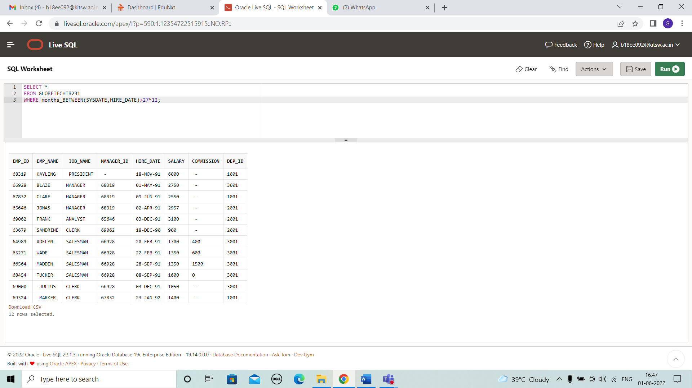

**CASE 22:**

# SELECT *

# FROM globetechtb231

# WHERE SALARY<3500;

# OUTPUT:

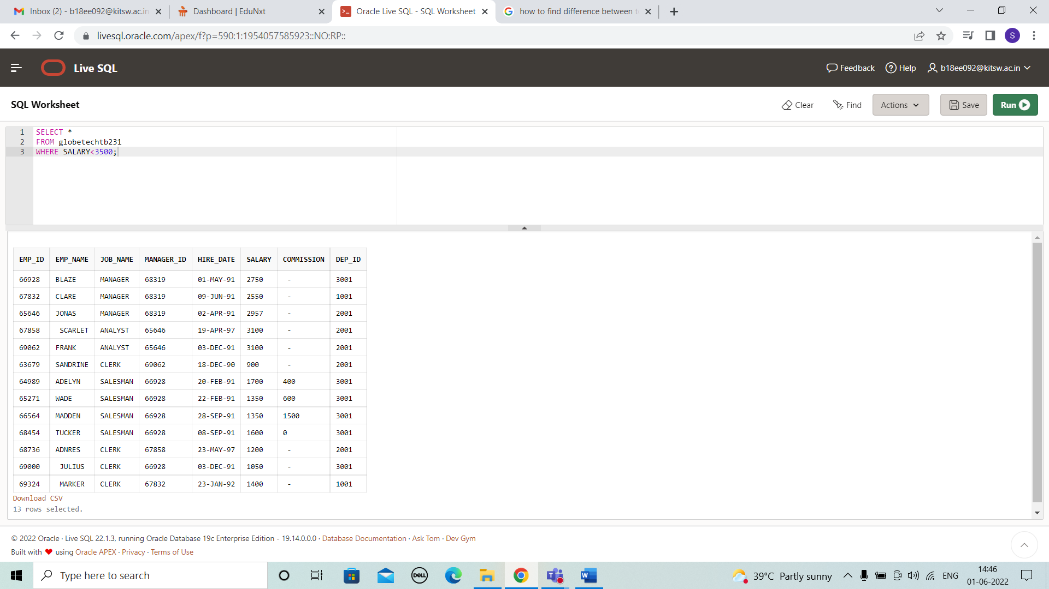

**CASE 23;**

# SELECT EMP_NAME,JOB_NAME,SALARY

# FROM globetechtb231

# WHERE JOB_NAME='ANALYST';

# OUTPUT:

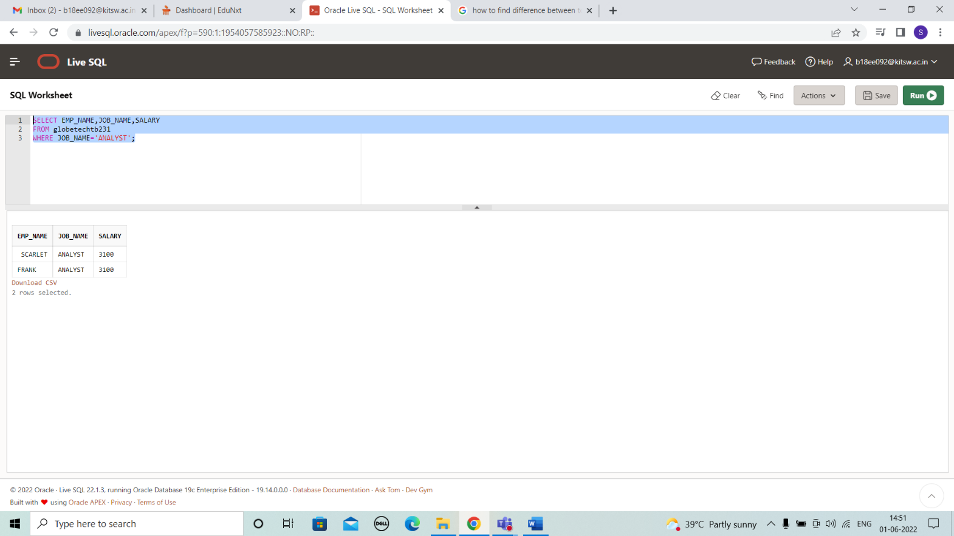

**CASE 24:**

SELECT *

FROM globetechtb231

WHERE to_char(hire_date,'YYYY')='1991';

**OUTPUT:**

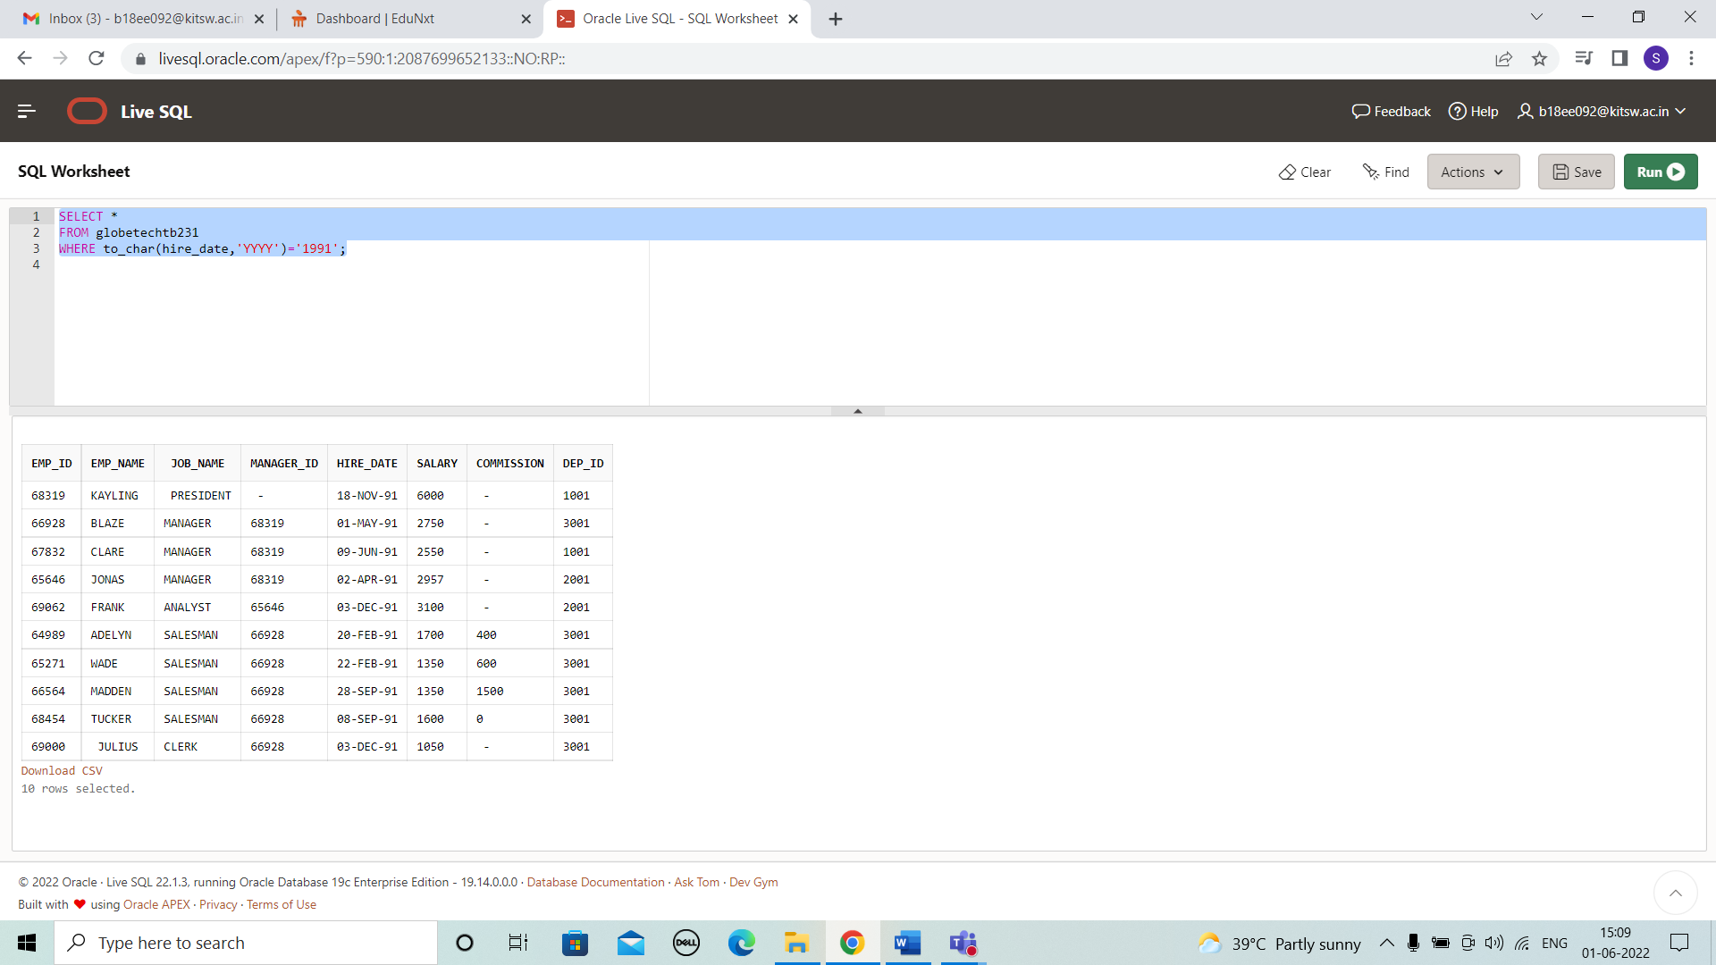

# CASE 25:

# SELECT EMP_ID, EMP_NAME, HIRE_DATE, SALARY

# FROM globetechtb231

# WHERE hire_date < DATE'1991-04-01';

# OUTPUT:

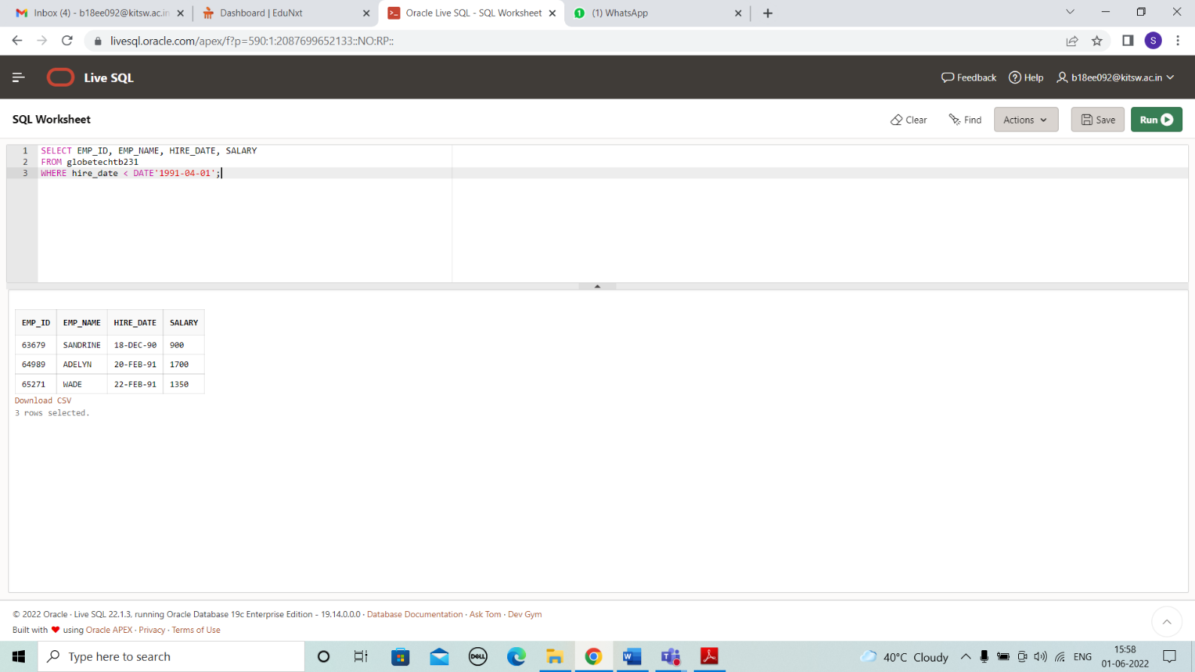

**CASE 26 :**

SELECT EMP_NAME, JOB_NAME

FROM globetechtb231

WHERE MANAGER_ID IS NULL;

# OUTPUT:

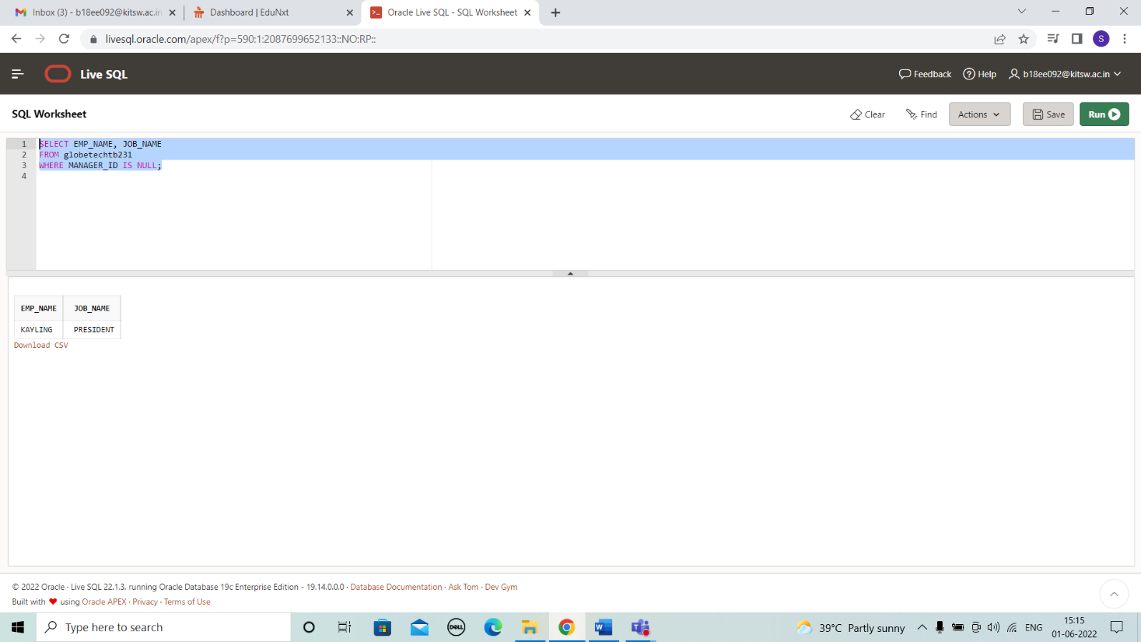

**CASE 27:**

SELECT * FROM globetechtb231

WHERE HIRE_DATE = '01-MAY-91';

**OUTPUT:**

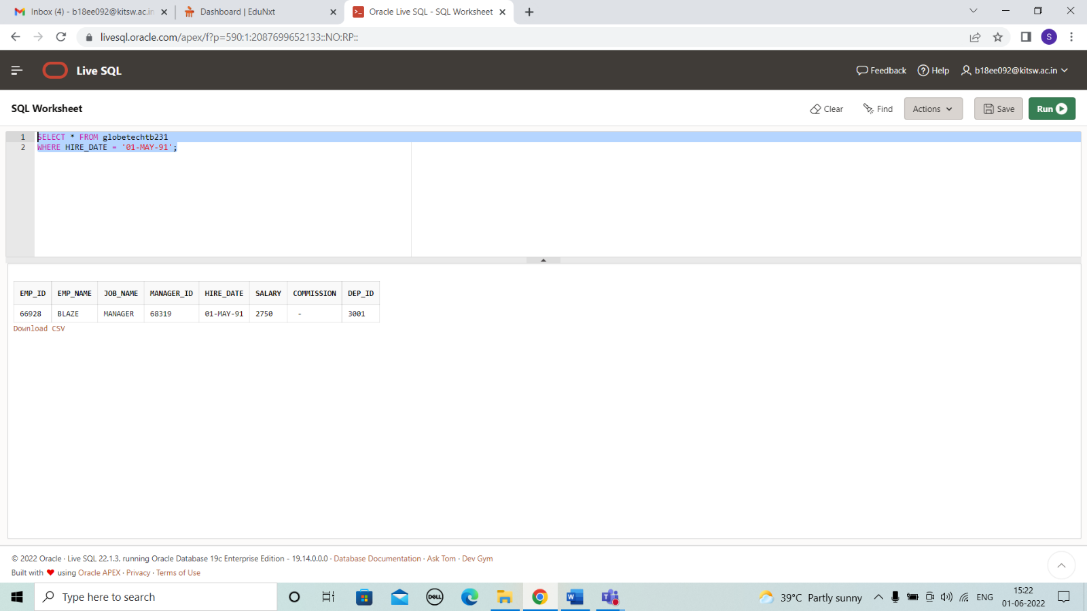

# CASE 28:

# select emp_id , emp_name , salary ,

# round(months_between(sysdate,hire_date)/12) as "Experience"

# from globetechtb231 where manager_id=68319;

# OUTPUT:

# 

# CASE 29:

select emp_id , emp_name , salary , round(months_between(sysdate,hire_date)/12) as "Experience"

from globetechtb231

WHERE (salary/30)>100;

**OUTPUT:**

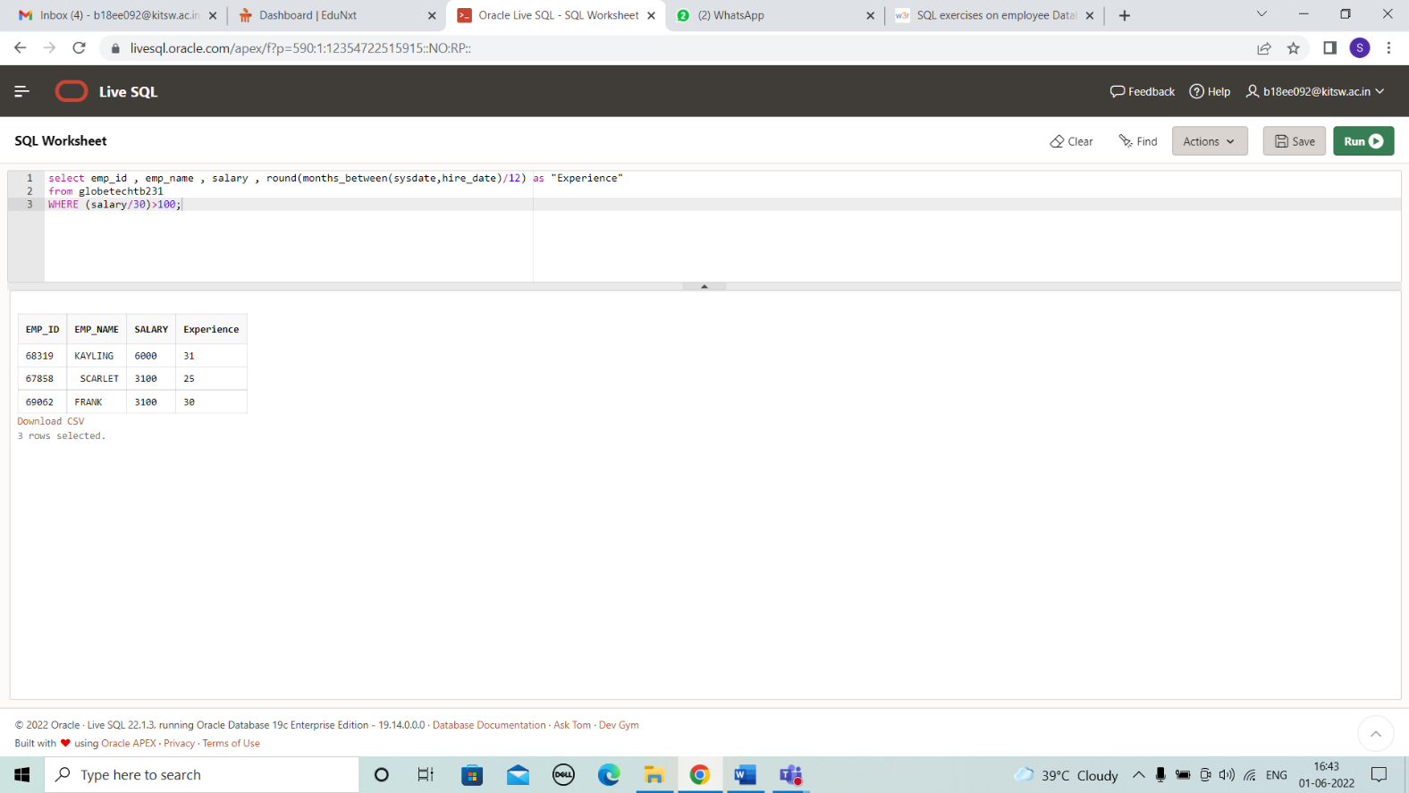

# CASE 30:

# select emp_name from globetechtb231

# where hire_date>to_date('1992-01-01','YYYY-MM-DD');

# OUTPUT:

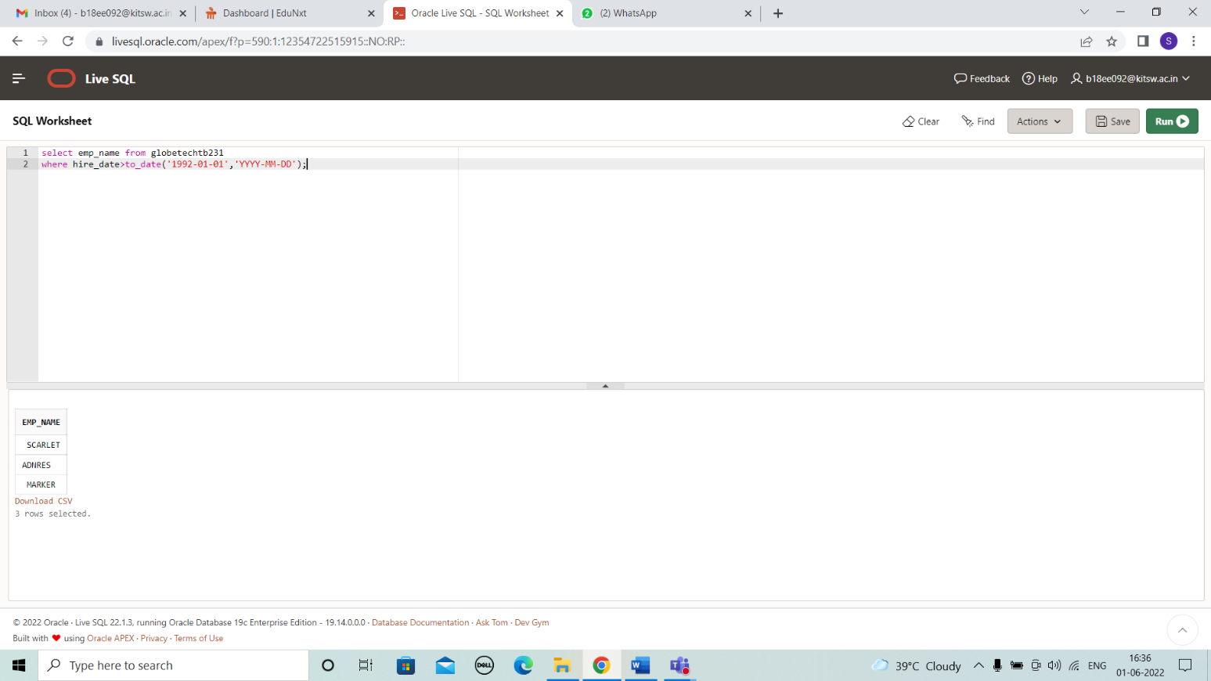

**CASE 31:**

SELECT *

FROM globetechtb231

WHERE mod(salary,2) = 1;

# OUTPUT:

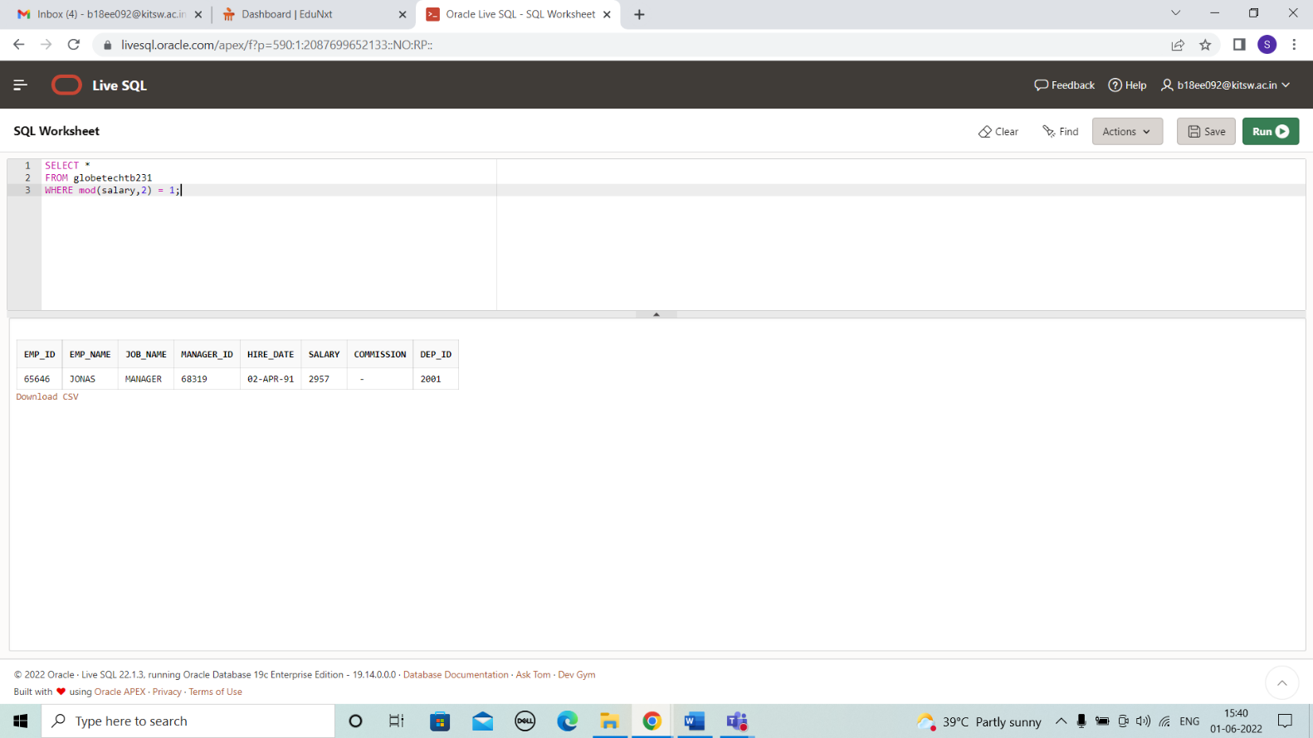

**CASE 32:**

SELECT *

FROM globetechtb231

WHERE length(TRIM(TO_CHAR(salary,'9999'))) = 3;

**OUTPUT:**

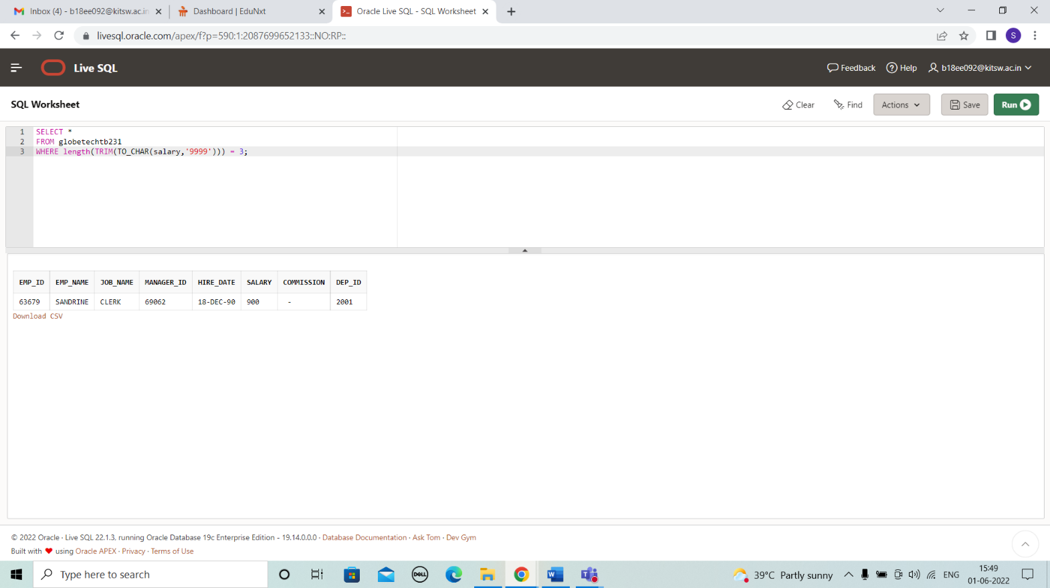

# RESULT

All the test cases have been solved and presented successfully in the present document.

# CONCLUSIONS

All the case studies have been solved successfully with all the concepts that have been covered in the training session. It’s really a great experience of learning while solving the cases. This case study gave me immense confidence regarding my ability to upskill in new technologies.

# REFERENCES

* https://[www.w3schools.com/sql/sql_count_avg_sum.asp](http://www.w3schools.com/sql/sql_count_avg_sum.asp)